Design Document for Project:
My project is a recreation of the Ambidex Game from Zero Escape: Virtue’s Last Reward, partially inspired by BrantSteele’s Hunger Games Simulator.
The Ambidex Game (shortened to A/B Game) is a numbers game of trust and betrayal, inspired by the prisoner’s dilemma, a common example of game theory. The dilemma is described as such by Wikpedia (see Figure A):
Two members of a criminal gang are arrested and imprisoned. Each prisoner is in solitary confinement with no means of communicating with the other. The prosecutors lack sufficient evidence to convict the pair on the principal charge, but they have enough to convict both on a lesser charge. Simultaneously, the prosecutors offer each prisoner a bargain. Each prisoner is given the opportunity either to betray the other by testifying that the other committed the crime, or to cooperate with the other by remaining silent. The offer is:
If A and B each betray the other, each of them serves two years in prison.
If A betrays B but B remains silent, A will be set free and B will serve three years in prison (and vice versa).
If A and B both remain silent, both of them will only serve one year in prison (on the lesser charge).
The A/B Game from Virtue’s Last Reward takes this concept and runs with it. Here are the rules of the A/B Game, shortened and condensed due to the smaller scope of my project:
- There are 9 players in the game, each of which start with 3 BP (Bracelet Points.)
- The ultimate goal of the game is to reach 9 points and leave the facility.
- If any player drops to or below 0, they will be killed via lethal injection from their bracelets.
During the A/B Game:
- The players will be shuffled and split off into 6 groups:
  - 3 solo players
  - 3 groups of 2
- Each group is also assigned a color of either Red, Blue or Green, so the final listing of groups is Red Solo, Red Pair, Blue Solo, Blue Pair, Green Solo, and Green Pair.
- The pairs and solos will be pitted against each other (either randomly, or the player can choose a “layout” to choose (Table B))
- (remember the Prisoner’s dilemma earlier? Here’s where that comes in.)
- Each PAIR and SOLO can choose to Ally with their opponent, or Betray them. (Figure C)
- If X is a Pair and Y is a Solo:
  - If X and Y both Ally, each party gains 2 points.
  - If X Allys and Y Betrays, Y gains 3 points while the members of X lose 2 points.
  - If Y Allys and X Betrays, Y gains 3 points while the members of X lose 2 points.
  - If both X and Y decide to Betray, their scores don’t change.
- The results from the voting are displayed to the players. (Table D)
- Any killing/escaping takes place here.
I’ve worked on this project privately on-and-off over a few days, and the logic and numbers-management sections of the game (adding and subtracting points as determined by the results of RNG) are feature-complete. Here is what I want to add:
- A graphical interface, as everything is text-based as of this writing
- Dialogue and events from other players in between A/B rounds
  - Having “personality” attributes that affect their actions, both during dialogue and in the A/B voting
- Have the player “take over” as one of the characters, influencing their decisions during the simulation
- Saving a graphical chart of each round to the game directory (for future reference) (Figure E)
- Saving a “game log” of all the events of the A/B Game
- Original music/compositions, given I have spare btime
Figure A: Prisoner’s dilemma payoff matrix from Wikipedia
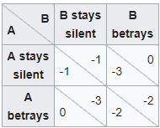
Table B: The “layout” options.
Option A | Red Pair v. Blue Solo | Blue Pair v. Green Solo | Green Pair v. Red Solo
Option B | Red Pair v. Green Solo | Blue Pair v. Red Solo | Green Pair v. Blue Solo
Option C | Red Pair v. Red Solo | Blue Pair v. Blue Solo | Green Pair v. Green Solo

Figure C: The A/B Game’s payoff matrix as shown in Virtue’s Last Reward
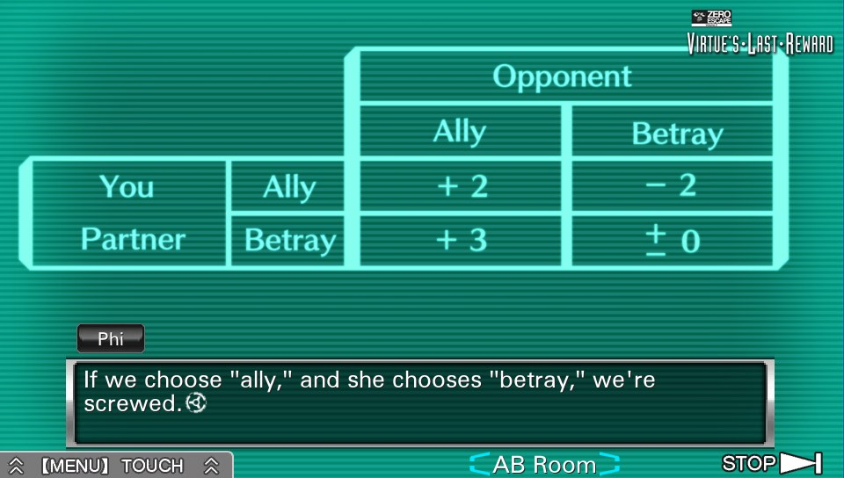
Table D: The post-round table (text)
Groups | Red Pair |  | Blue Solo | Blue Pair |  | Green Solo | Green Pair |  | Red Solo
Names | Alph | Brittany | Charlie | Delilah | Elliot | Faith | Graham | Hanna | Ian
Points | 6 | 5 | 3 | 1 | 3 | 3 | 1 | 5 | 3
A/B | Ally |  | Betray | Ally |  | Ally | Betray |  | Betray
Change | -2 |  | +3 | +2 |  | +2 | 0 |  | 0
Final Pts. | 4 | 3 | 6 | 3 | 5 | 5 | 1 | 5 | 3

Figure E: The post-round table as an image (conceptual)
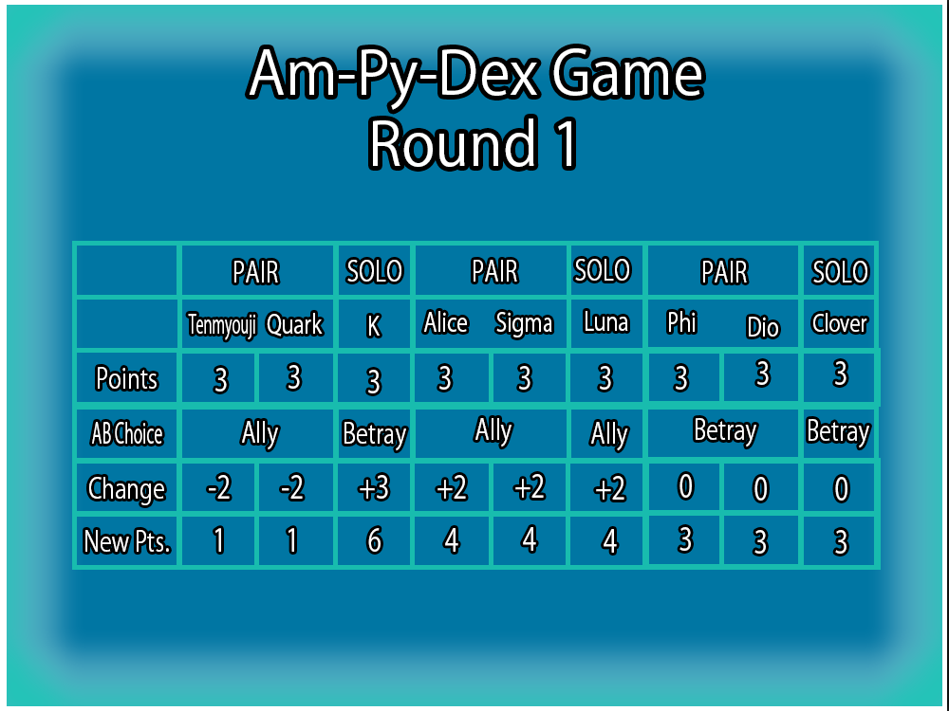
Note: Zero Escape, Virtue’s Last Reward, and all related assets are © Spike-Chunsoft. I do not claim any rights to their property.

